Azure Resource
- Object used to manage services in Azure
- Represents service lifecycle
- Saved as JSON definition as “Metadata”
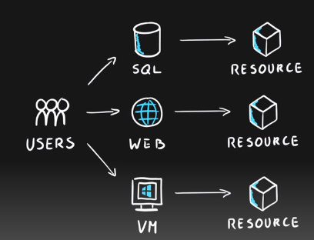


Resource Groups
- Grouping of resources
- Holds logically related resources
- Typically organizing by
  - Type
  - Lifecycle (app, environment)
  - Department
  - Billing,
  - Location or
  - combination of those
- They are free.
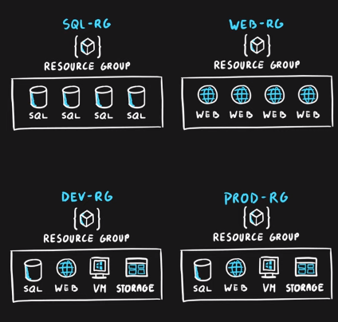

Resource Manager
- Management Layer for all resources and resource groups
- Unified language
- Controls access and resources
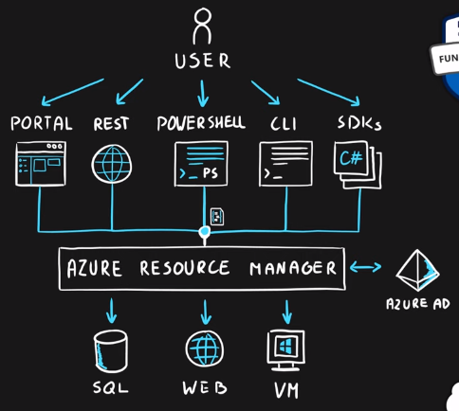

Additional Info
- Each resource must be in one, and only one resource group
- Resource groups have their own location assigned
- Resources in the resource groups can reside in a different locations
- Resources can be moved between the resource groups
- Resource groups can’t be nested
- Organize based on your organization needs but consider
  - Billing
  - Security and access management
  - Application Lifecycle

